Insights Discovery for Microsoft Teams

User guide



This guide supports IT teams with the initial setup, while also providing guidance for practitioners who administer Insights Discovery and end users who interact with the Insights Discovery for Microsoft Teams application.
Contents
How to add the app to Microsoft Teams 3
App Permissions 3
User Permissions 6
Setup Policies 6
Restricted User Permissions 6
Profile Import 7
Profile privacy settings 9
Different scenarios of what you may see dependent on profile imports and privacy settings 12
App not installed 15
Dashboard functionality 16
Overview of colour energy order 17
Highlights, strengths and possible weaknesses 18
Weekly insights 18
Upcoming meetings 18
Present now 19
Adding app to meetings 20
Meeting dashboard and chat drop downs 23
How to view and compare profiles 26
In a meeting chat 26
During a meeting 29
Set up Avatar 30
Language settings 32
Troubleshooting 32
Application Functionality 32
Profile Import Issues 33
FAQs 35
Application Functionality 35
General 35
Security 36
Technology 37

How to add the app to Microsoft Teams

This will have to be done by your IT team or Microsoft administrator.
- Download ‘Insights Discovery’ app from the Microsoft Teams Admin Centre.
- Once you have downloaded ‘Insights Discovery’, it should appear under ‘Apps – Added by your org’
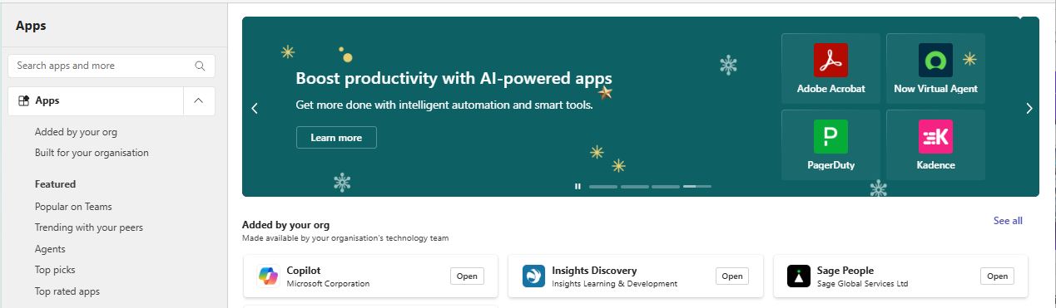

App Permissions

This will have to be done by your IT team or Microsoft administrator.
- Access the Microsoft Teams Admin Center and locate the navigation menu on the left-hand side of the dashboard.
- From here, click on the ‘Teams apps’ option and select ‘Manage apps’. 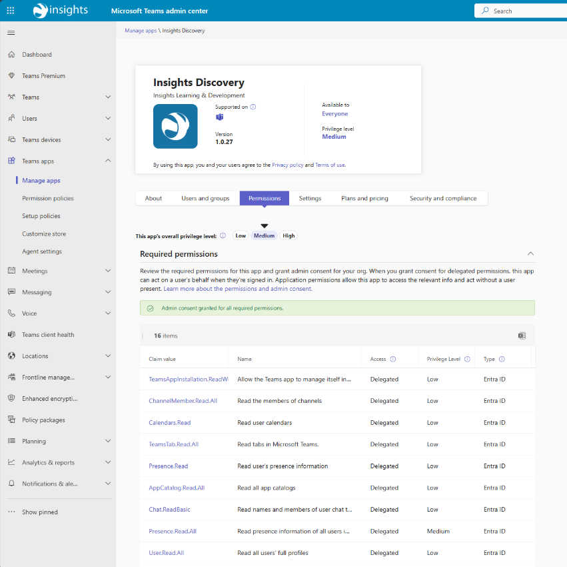
- Search for ‘Insights Discovery’
- Select the app
- Grant admin consent for all required permissions 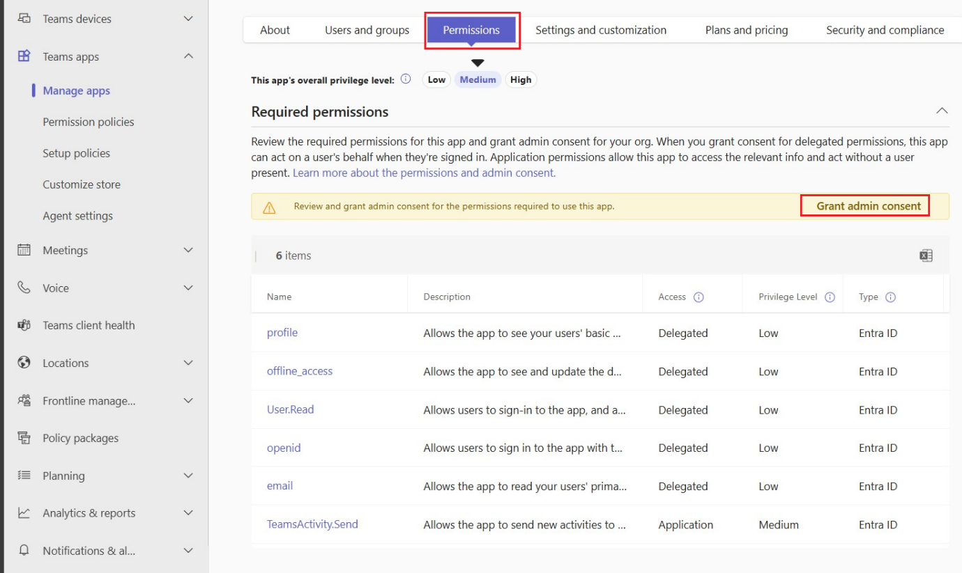
For more information on granting and managing consent to Teams app permissions, see here.
For the full permissions list, please refer to the setup guide.

- Go to Teams apps → Permission policies
- Select the policy assigned to your users (for example, Global (Org-wide default))
- Ensure the ‘Insights Discovery’ app is Allowed and save any changes.
If the app is blocked in a permission policy, users will not be able to access it even if the app itself is allowed – see here for full instructions.
- Wait for changes to apply as it may take up to several hours to show across Microsoft Teams.
Note: Allowing an app makes it available for deployment but does not automatically install it for users. App deployment is managed separately using setup policies.

User Permissions

This will have to be done by your IT team or Microsoft administrator.

Setup Policies
- Go to Teams apps → Setup policies
- Select an existing setup policy or create a new one
- Under Installed apps, add ‘Insights Discovery’
  - (Optional) Under Pinned apps, pin ‘Insights Discovery’ to the Teams app bar – see here for full instructions.

- Assign the setup policy to users or user groups. This ensures the app is automatically installed and/or visible for users in Microsoft Teams – see here for full instructions.

Restricted User Permissions
- Go to Teams apps → Permission policies
- Select an existing policy – like Global (Org-wide default) – or create a new policy by selecting ‘Add’
- Name the policy (for example: Marketing App Access)
- Under ‘Allowed apps’, you can:
  - Select ‘Allow all apps (default)’
  - Or choose ‘Allow specific apps and block all others’

- Search ‘Insights Discovery’ and add it to the list
  - Block other apps if necessary
This ensures that only the apps you specify are available to users assigned to this policy.
- With the policy selected, choose ‘Manage users’
- Click ‘Add users’
- Search for and select the individuals or groups you want to restrict access to
- Confirm your selection
  - Only the users assigned to this policy will be able to use Insights Discovery.
- Ask assigned users to restart Teams if the app does not appear immediately
  - Changes can take up to 24 hours to update fully.

See here for further information from Microsoft on using app permission policies to control user access to apps.

Profile Import

When ‘Insights Discovery’ is installed in your Microsoft Teams account:

- Click on ‘Insights Discovery’ using the navigation pane on the left-hand side (if it does not appear, select ‘Apps’, search ‘Insights Discovery’ and select it).
- You will see this window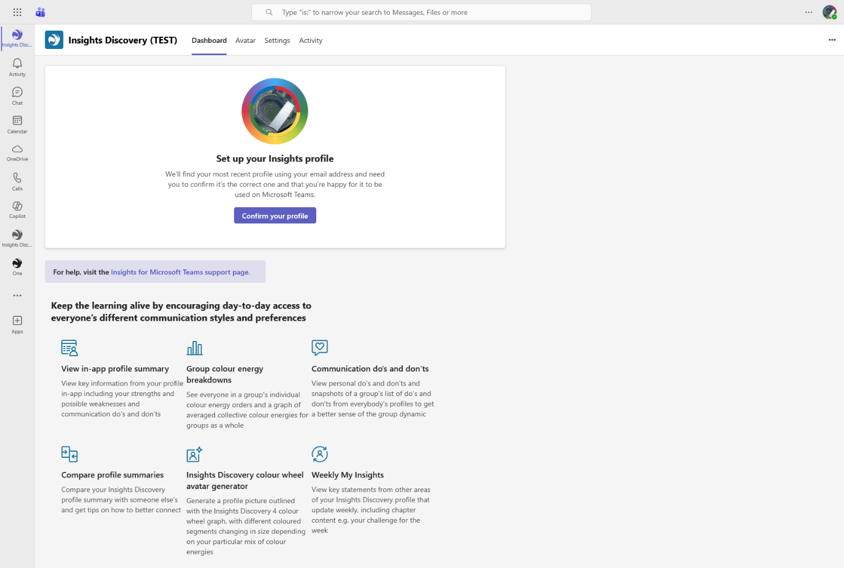
- Click ‘Confirm your profile’
  - If your Microsoft Teams account email matches the email address you used to receive your profile, your most recent profile will populate, as shown here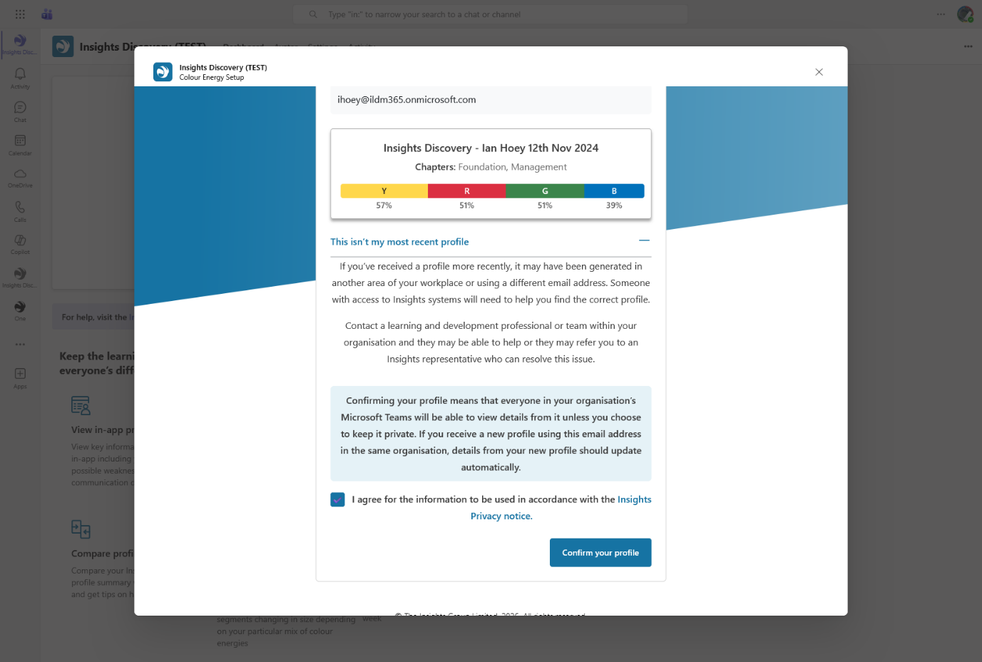
If your profile does not import, please refer to Profile import issues.

- Once you have confirmed your profile, you will see a dashboard that populates your profile information, as shown below. 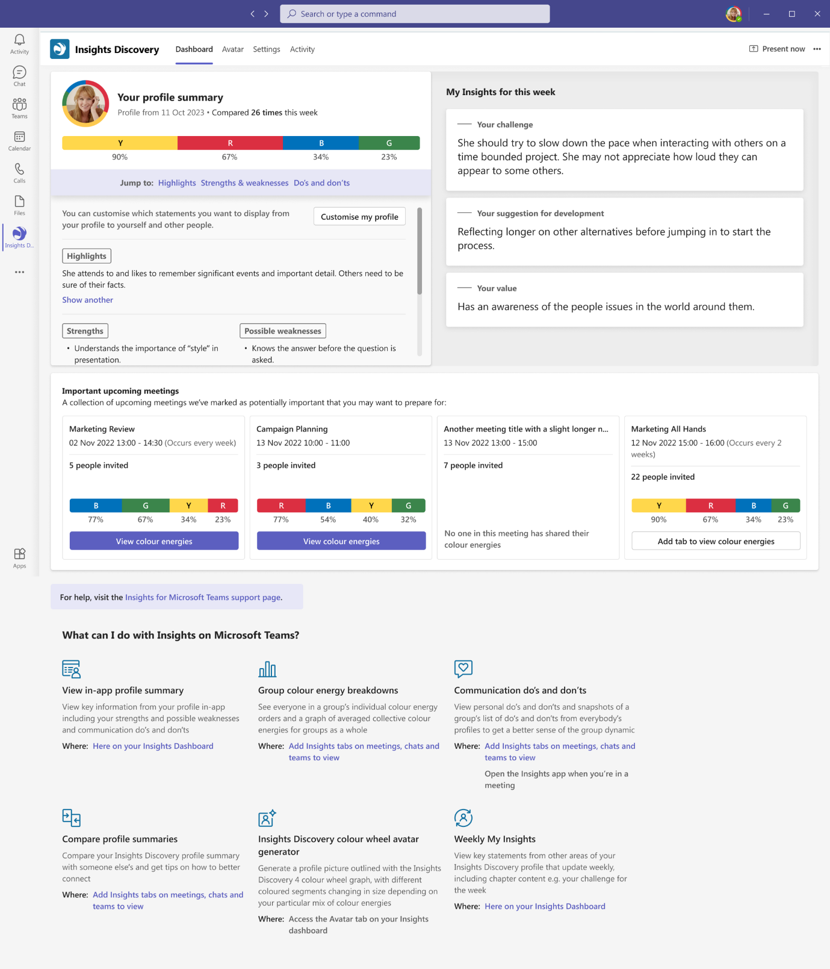

Profile privacy settings

- In your ‘Settings’ (accessed by clicking ‘Settings’ in the top navigation bar), you can decide:
  - Who can view elements of your profile (including your colour energy order)
  - What type of meetings appear in your dashboard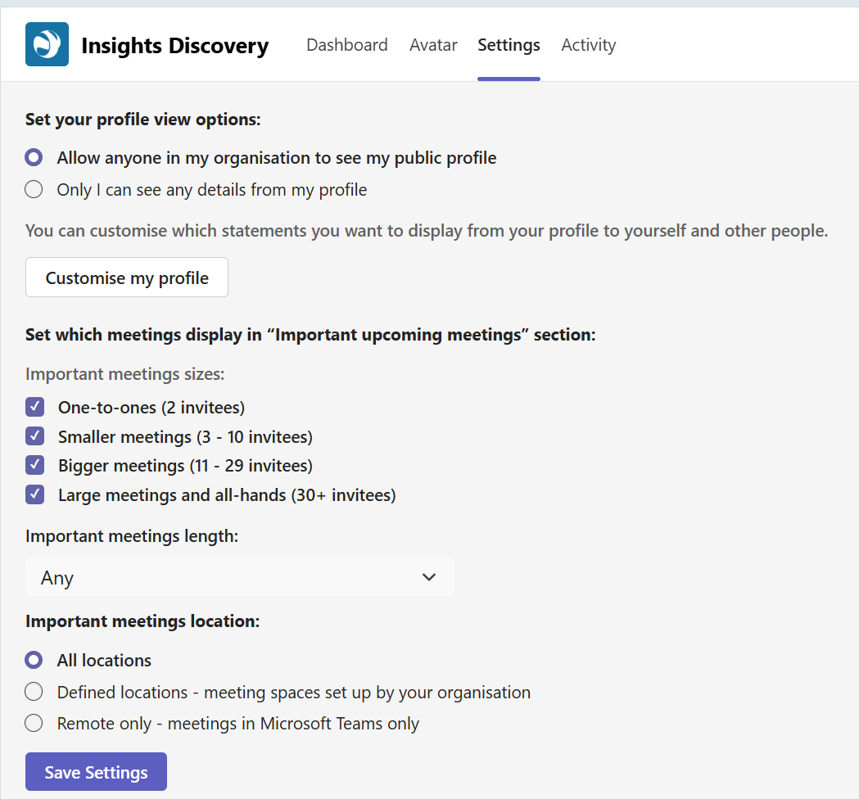
- In the same view as above (as well as from your Dashboard – screenshot below),
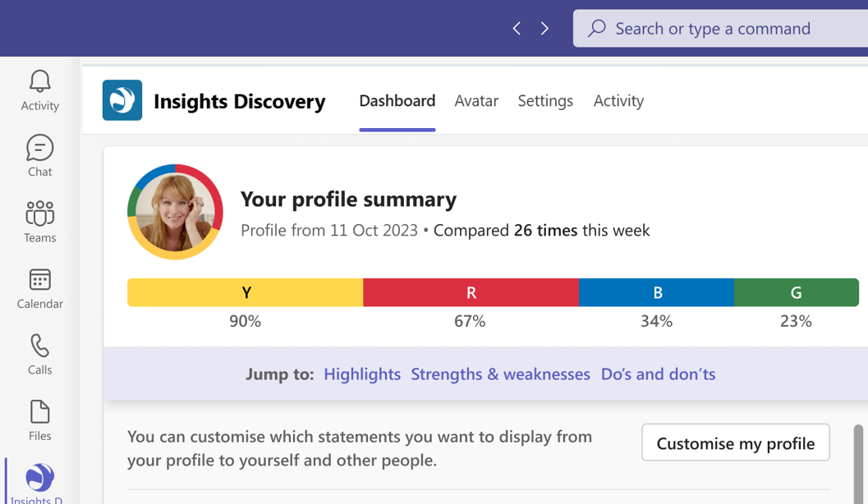

- You can click ‘Customise my profile’ to choose which statements from your profile are available to only you or others from your organisation. 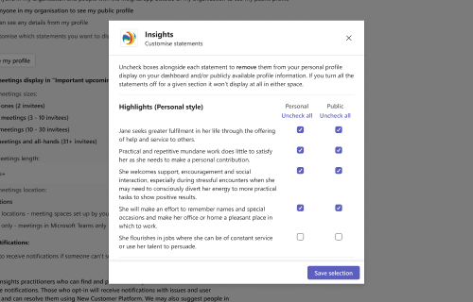

Different scenarios of what you may see dependent on profile imports and privacy settings
- Scenario 1: Iain English and Ian Hoey both have Discovery profiles, Ian Hoey has not imported their profile 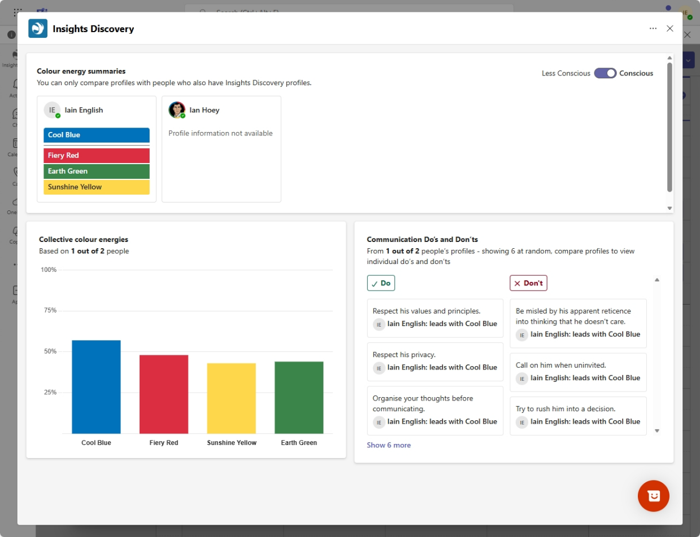

- Scenario 2: Iain English and Ian Hoey both have Discovery profiles and both confirm privacy settings as open
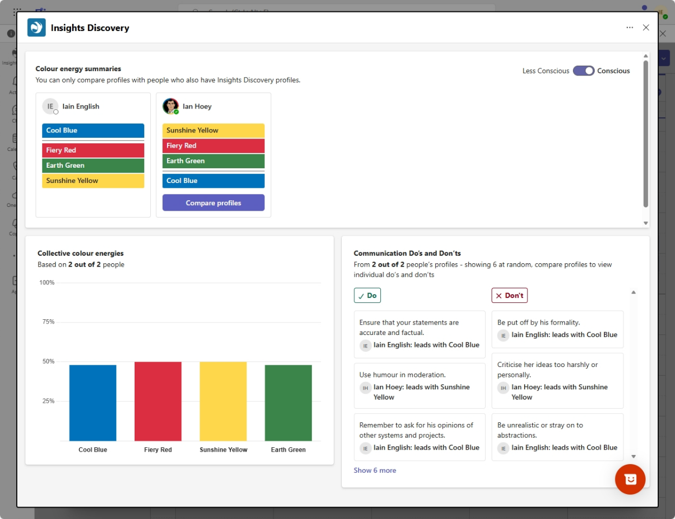

- Scenario 3: Iain English and Ian Hoey both have NCP profiles, Ian Hoey has privacy settings as private
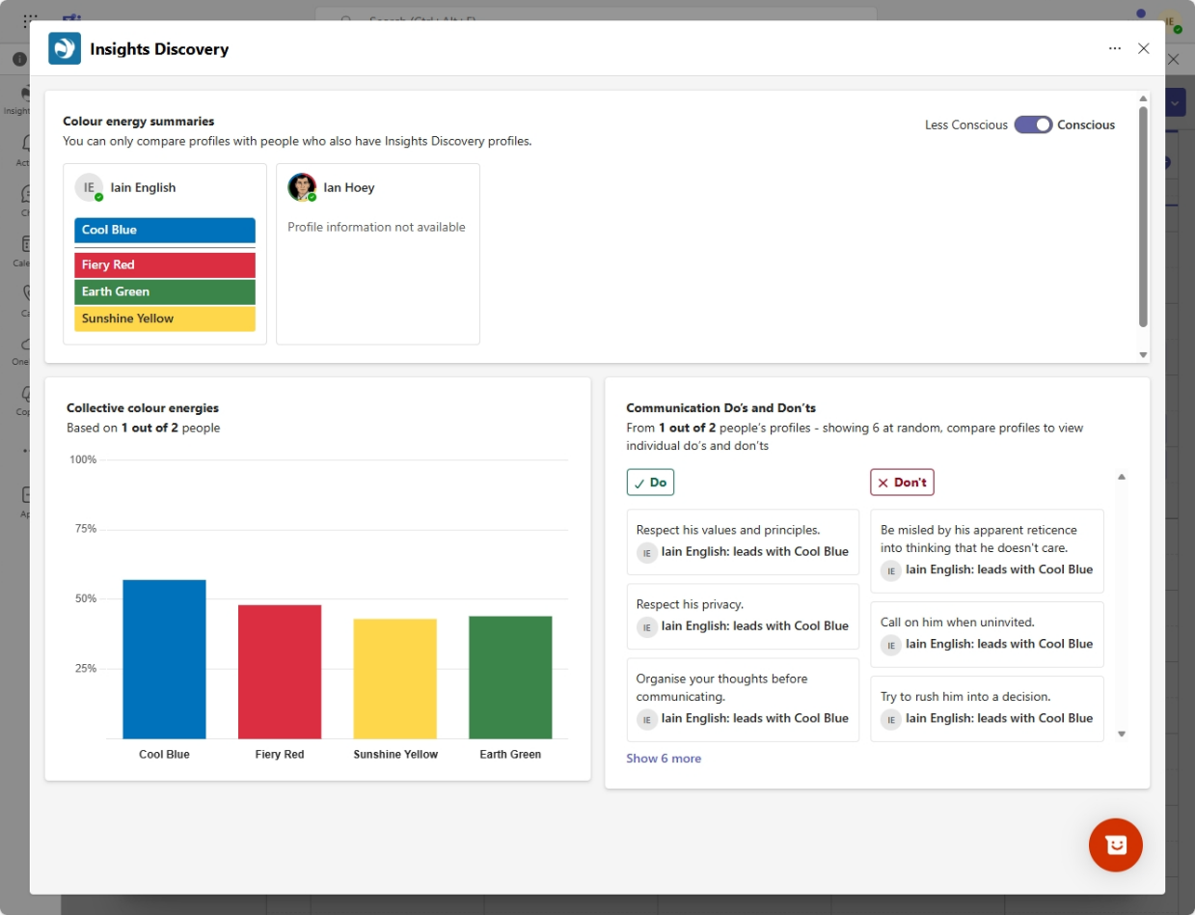

- Scenario 4: Iain English has a Discovery profile, Ian Hoey does not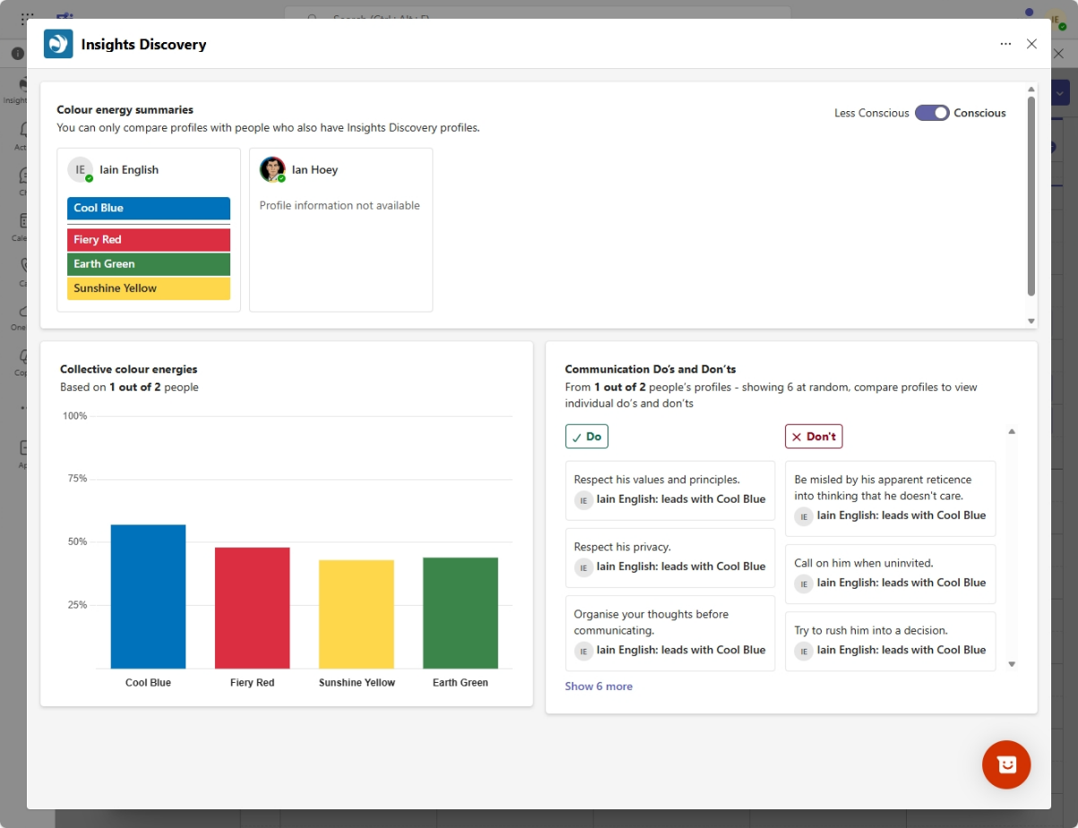

App not installed
- If a colleague does not have the app installed on their MS Teams, this is what they would see in a meeting where the Insights Discovery for MS Teams app has been added to a meeting chat:
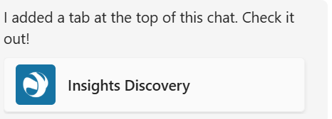
- If a colleague does not have the app installed on their MS Teams, this is what they would see in a meeting where the Insights Discovery for MS Teams app has been added to a meeting chat and they clicked on the app:
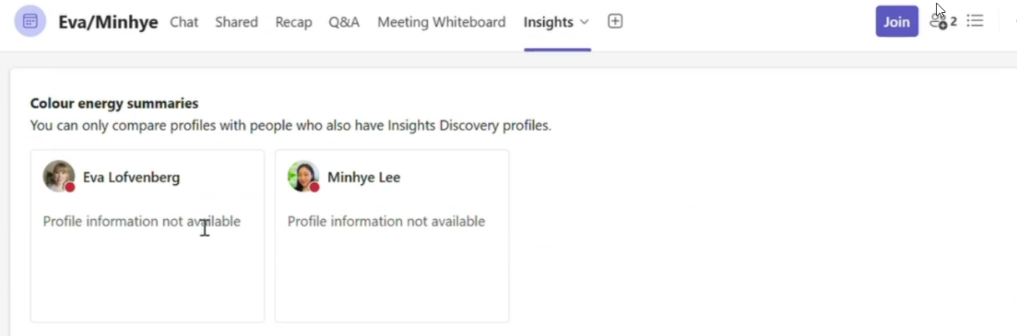

- A colleague – in this instance it is ‘iain (test)’ – who does have the app installed but does not have a profile, would see this in a meeting where the Insights Discovery for MS Teams app has been added to a meeting chat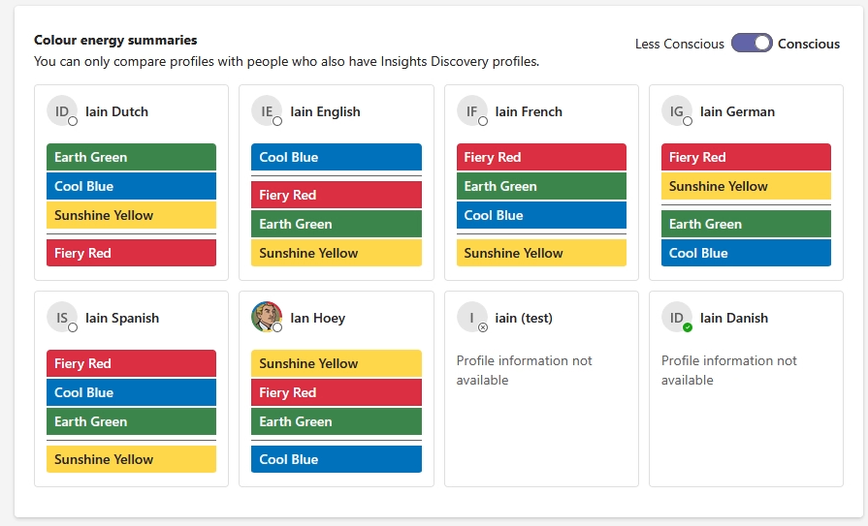

Dashboard functionality
Information from your Discovery profile: showing an overview of colour energy order, highlights, strengths, challenges, weekly insights, upcoming meetings

Overview of colour energy order
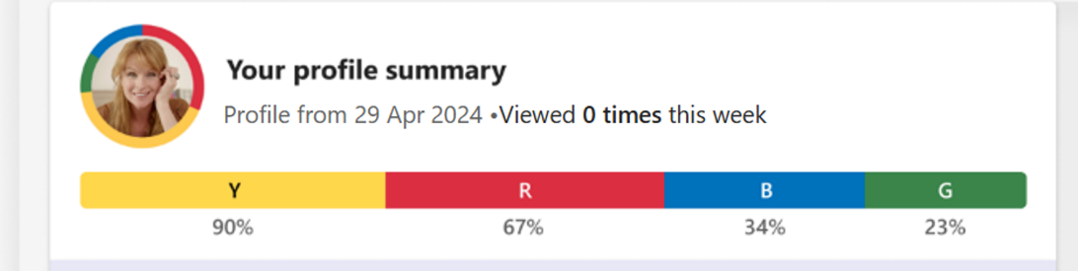
Your colour energy order and percentages update automatically if you receive a new Discovery profile.
The ‘Viewed 0 times this week’ statement is related to the number of times someone in your organisation compares their profile to yours. This can be done when viewing the Insights Discovery tab in a meeting. For more information on this, see How to view and compare profiles – During a meeting.

Highlights, strengths and possible weaknesses
The statements shown are pulled directly from your Discovery profile. By using the scroll bar, you can select to show all of the statements under each heading (Strengths, Possible weaknesses, Communication do’s and don’ts).

By clicking on ‘Customise my profile’, you can select which statements are only available to you and/or made available to other people in your organisation. For more information, see Profile privacy settings.

Weekly insights
The statements shown are pulled directly from your Discovery profile. This automatically refreshes every week.

Upcoming meetings
The meetings shown are pulled directly from your Outlook calendar. You can tailor the types of meetings shown by selecting ‘Customise your profile’ in your Dashboard view. For more information, see Profile privacy settings.

You can view the colour energies make up of all meeting attendees from here, as well as add the Insights Discovery app to a meeting. For more information, see Adding app to meetings.

Present now
If you are on a call and would like to share your Dashboard view, you can do so by selecting ‘Present now’, in the top right corner of the Insights Discovery screen.

You can invite someone at your organisation to access the app for themselves by clicking the three dots in the top right corner of the Insights Discovery screen and selecting ‘Share app’.
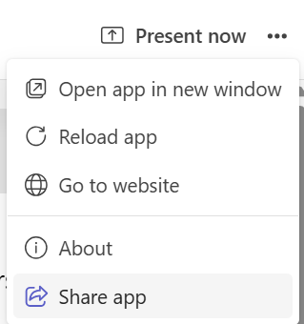
The pop up below will appear, allowing you to type the name of a person, group or channel you would like to share the app with. Alternatively, you can click ‘Copy link’. 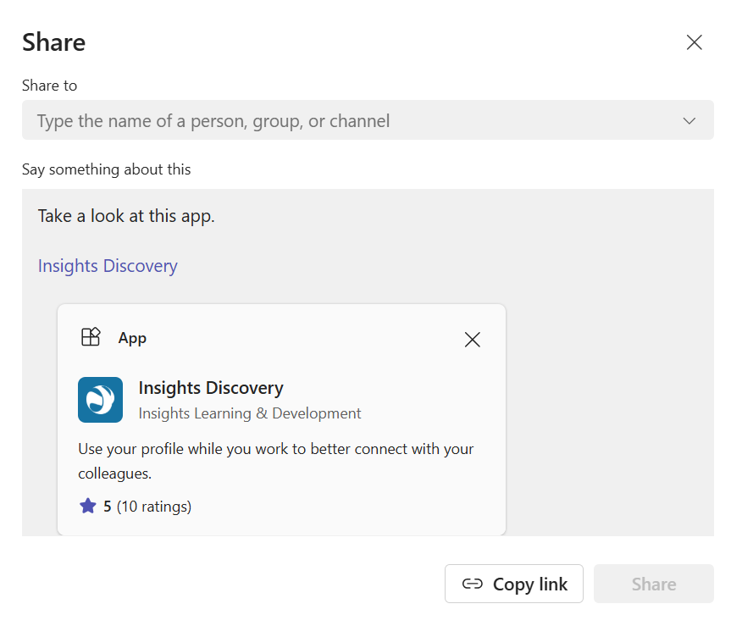

Adding app to meetings
- Go to your meeting chat in Microsoft Teams
  - You can access the meeting chat by going to your calendar
  - Right clicking the meeting
  - Selecting ‘Chat with participants’ 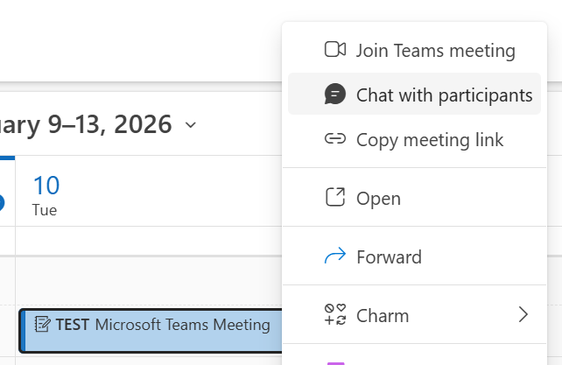

- Click the ‘+’ sign in the top navigation bar of the meeting chat

- Type in ‘Insights Discovery’ and select the app shown below
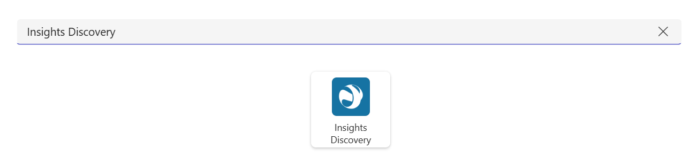
- This pop up will appear. Click ‘Save’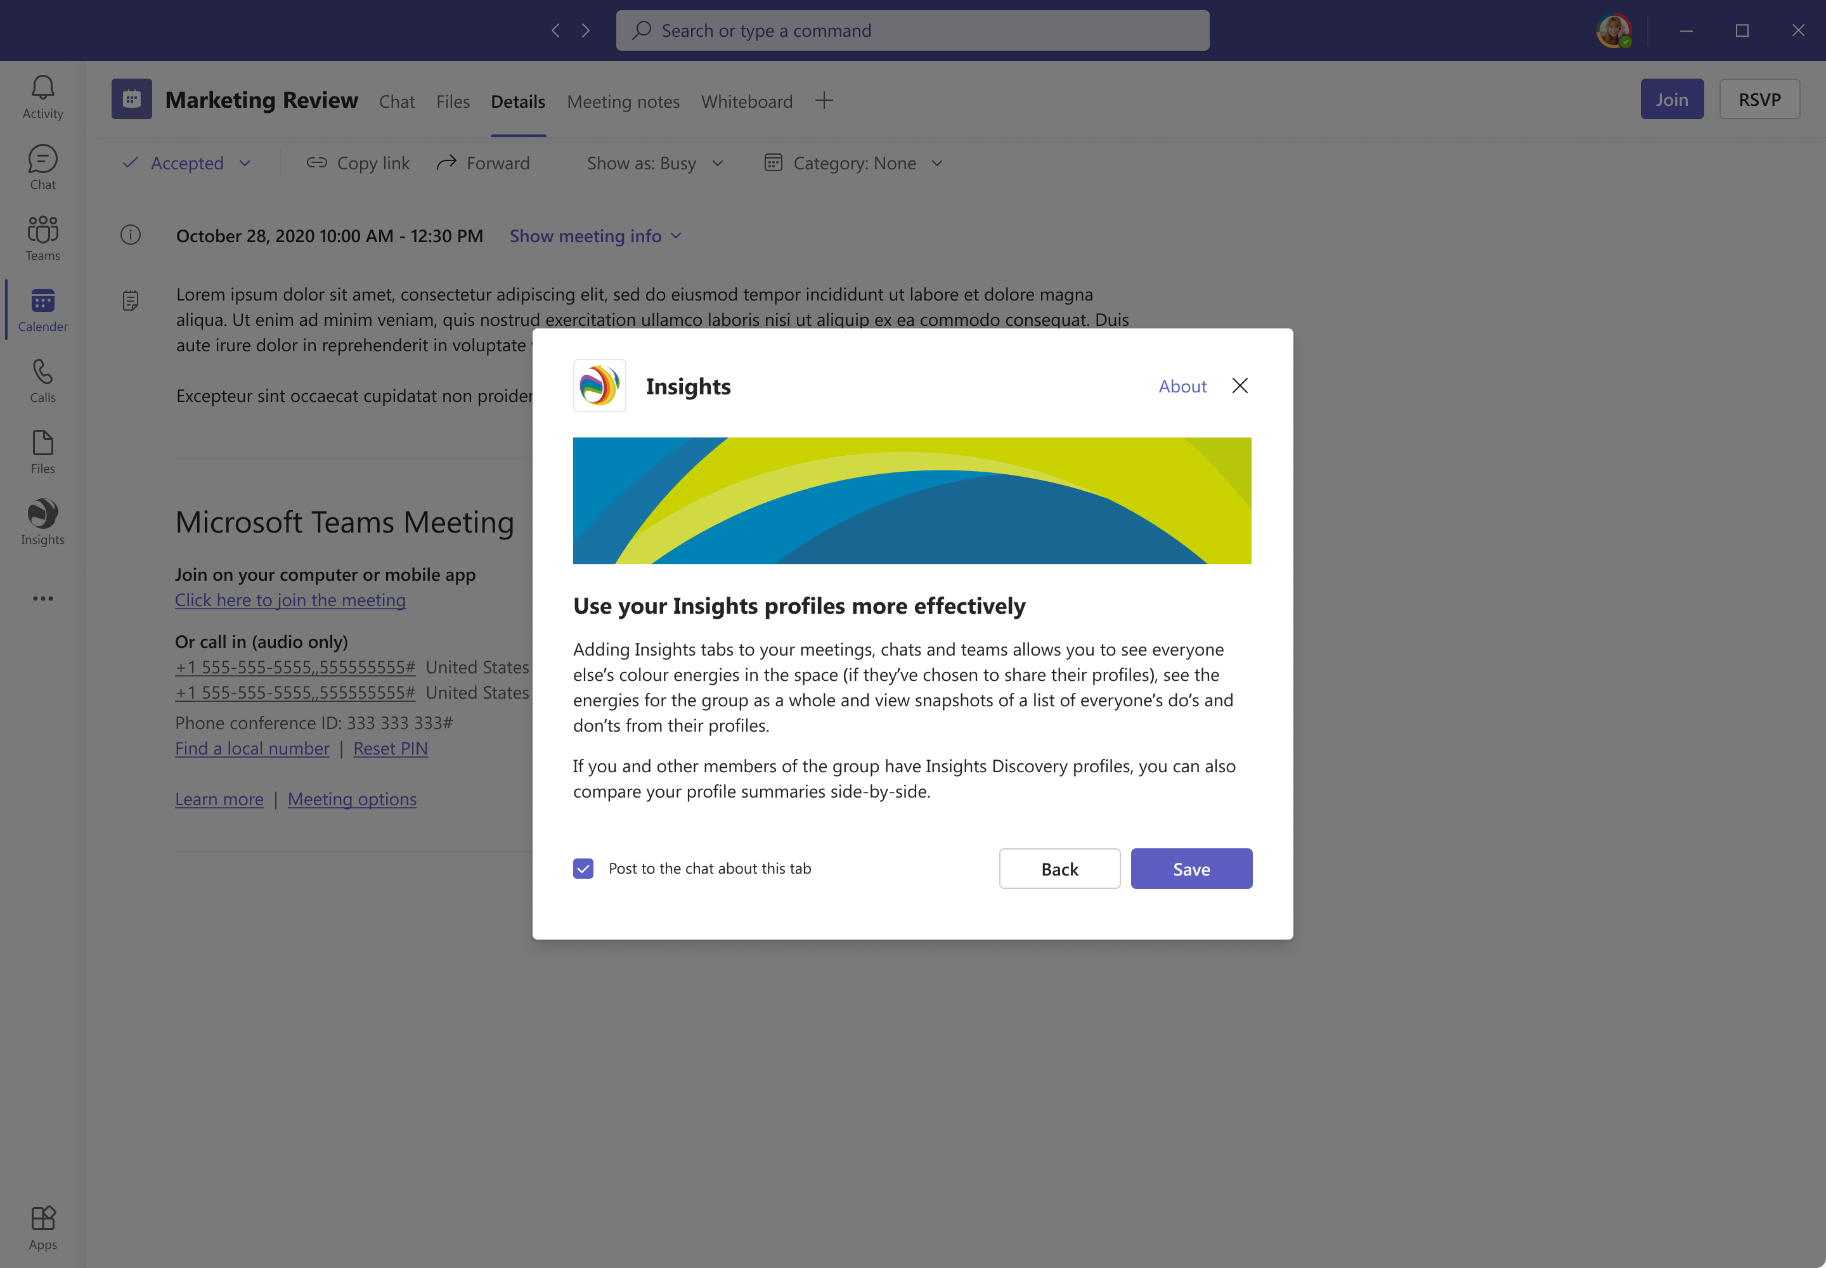
You will now see an overview of the colour energies and communication do’s and don’ts of everyone in the meeting that has a profile imported. If they:
- Do not have a profile imported
- Have set their profile to private
- Do not have access to the app
Their profile card will appear as ‘Profile information not available’ (e.g. Mark Jones in the image below)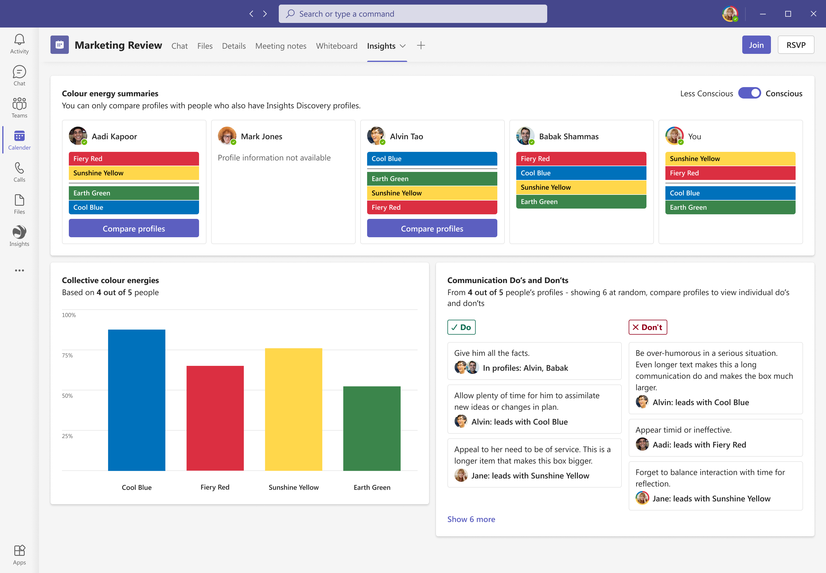

Meeting dashboard and chat drop downs
This is how the meeting dashboard will appear
If you select ‘Compare profiles’ with any individual, you will see the below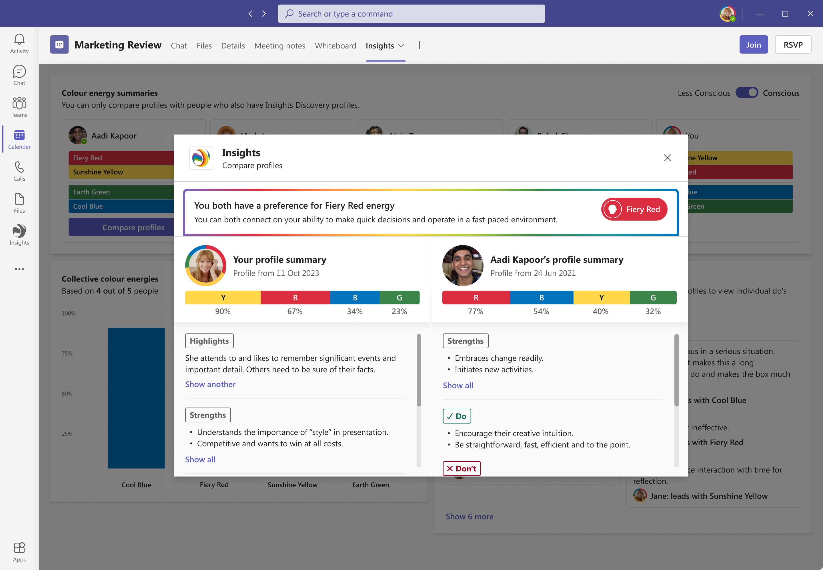
For instructions on how to compare profiles, refer to How to view and compare profiles.
During the meeting, when you click on the ‘Insights Discovery’ tab in the top navigation pane, the communication do’s and don’t’s of everyone in the meeting who has shared their profile will show in the chat dropdown section on the right
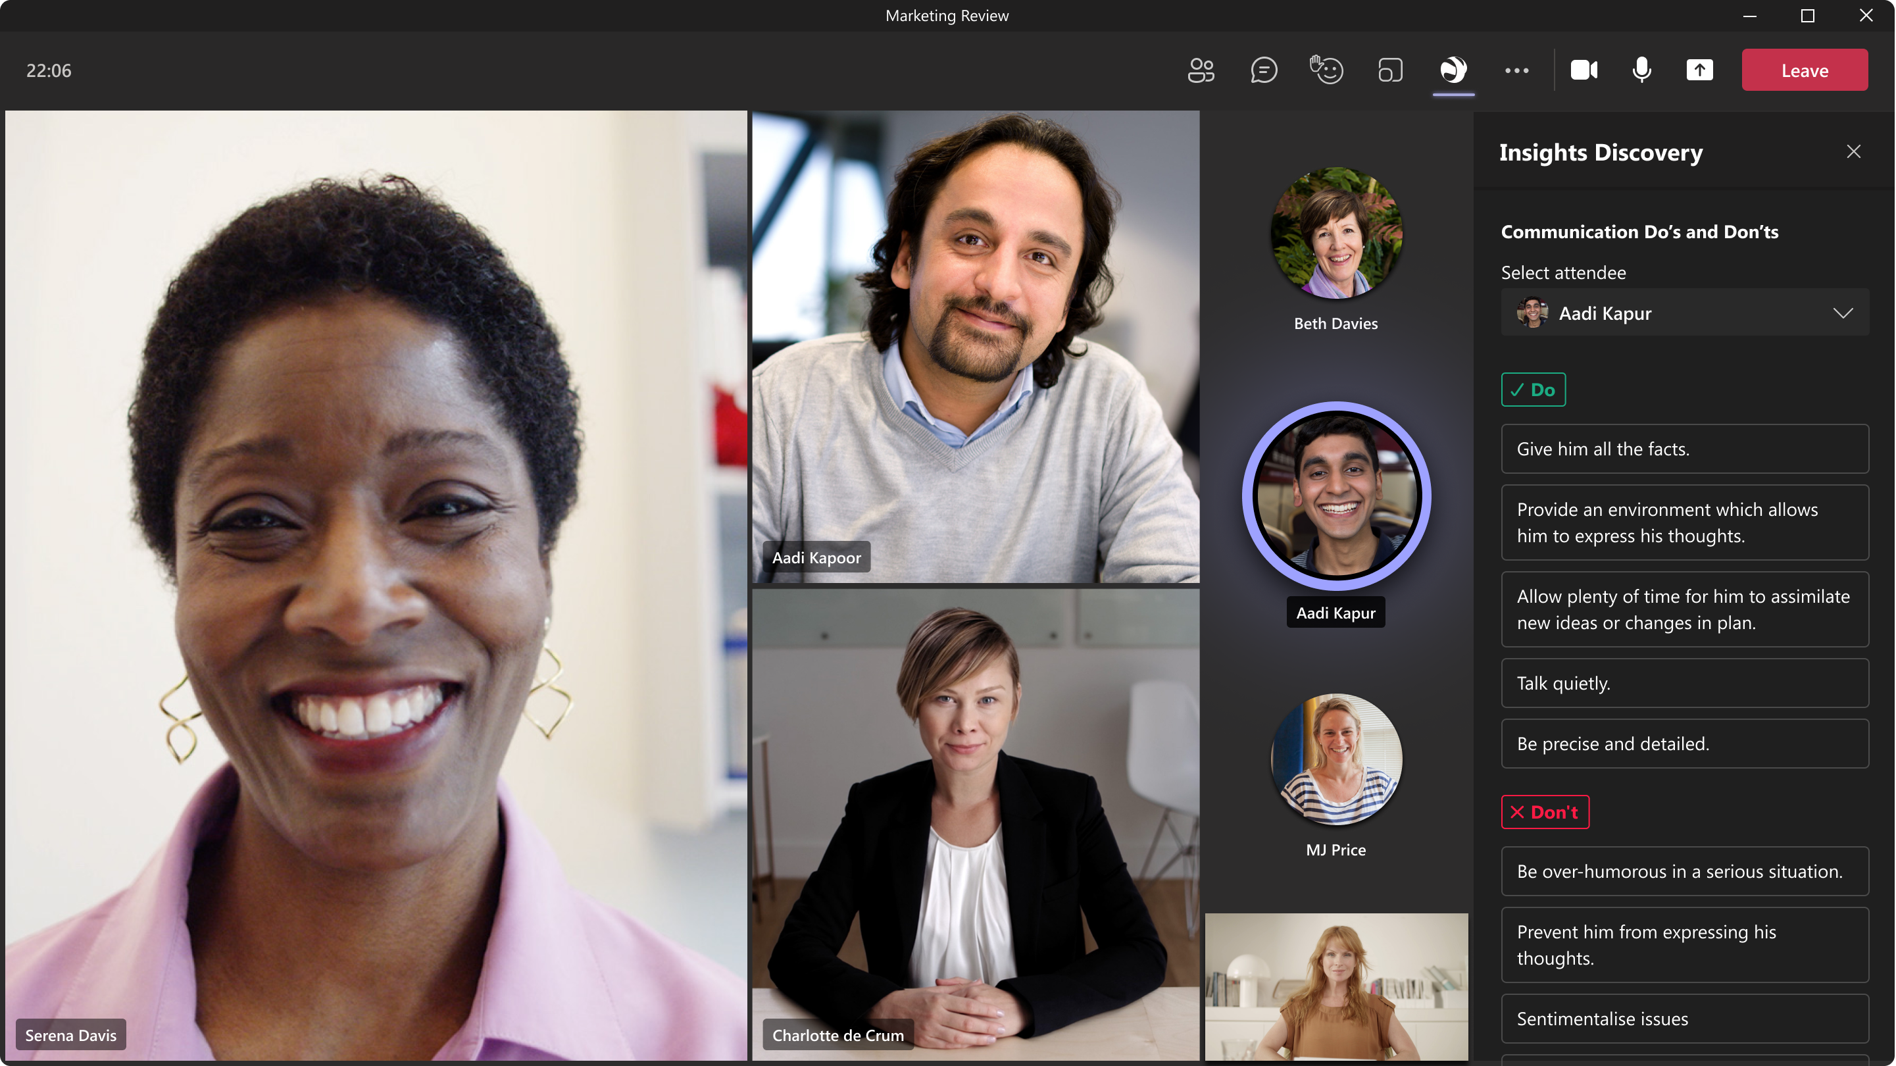

During the meeting, if you would like to see the meeting dashboard view again, you would need to:
- Minimise the Teams meeting call screen
- Go to your normal Teams chat view (the one that allows you to message anyone from your organisation)
- Select the meeting chat of the call you are currently in
- Select the app in the top navigation pane and the view below will appear

How to view and compare profiles

In a meeting chat
- Follow the steps from Adding app to meetings, if the Insights Discovery tab has not already been added to the meeting
- Select the Insights Discovery tab in the top navigation pane of the meeting chat 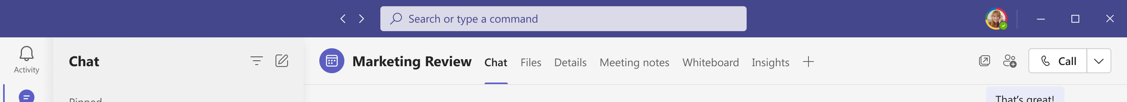
- You will now see an overview of the colour energies and communication do’s and dont’s of everyone in the meeting that has a profile imported
- By clicking ‘Compare profiles’, you will get a side-by-side comparison of your profile with the person you have selected
- You can also add the Insights Discovery app to a meeting by:
  - Going to your Dashboard
  - Looking at your ‘Upcoming Meetings’
  - Selecting ‘Add tab to view colour energies’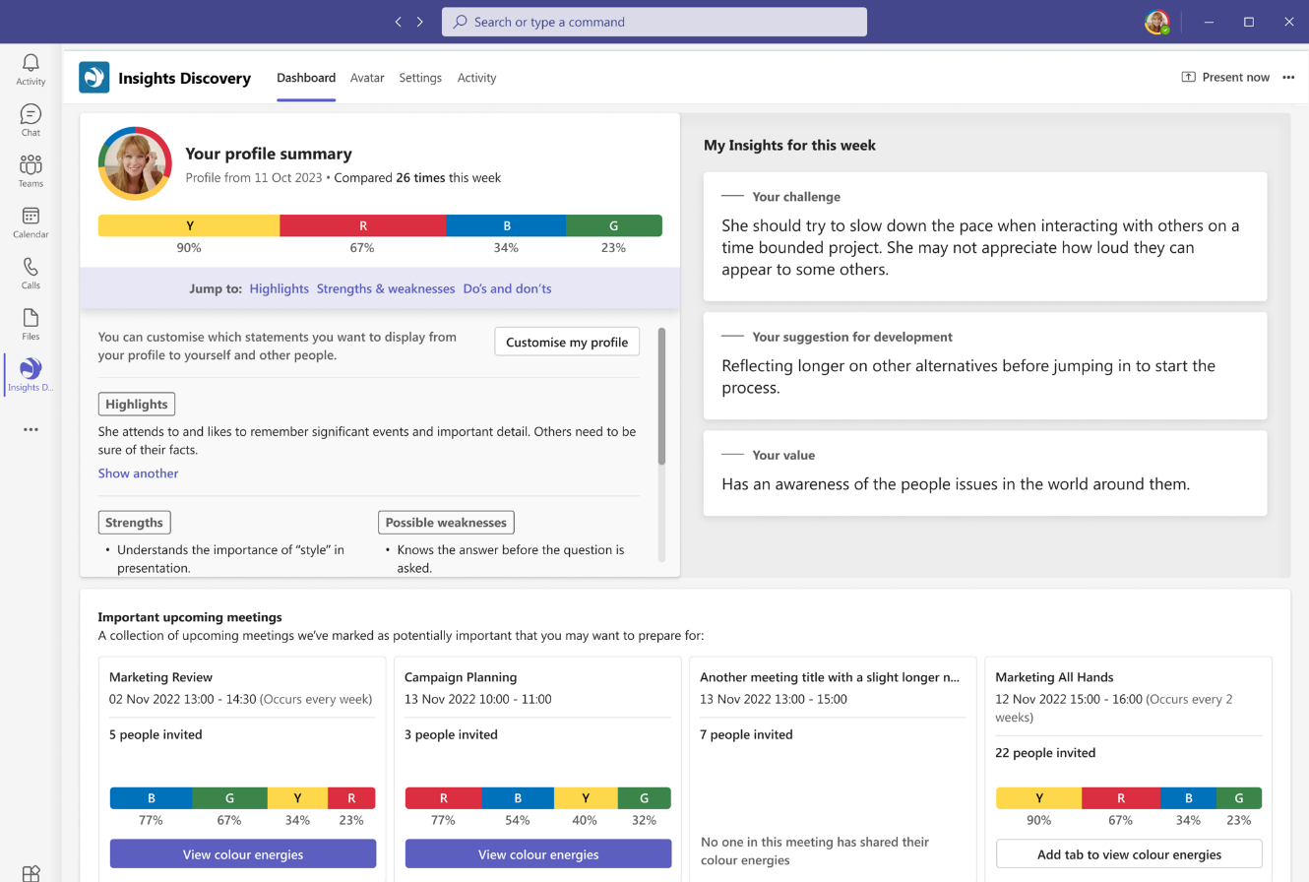

During a meeting
If the ‘Insights Discovery’ app has already been added to the meeting (if not, please follow the steps above in ‘In a meeting chat’, you can:
- Click on the ‘Insights Discovery’ tab located in the top right corner of the meeting.
The communication do’s and don’t’s of all meeting participants (who have imported their profile and shared their profile information) will appear on the right-hand side of the meeting screen.

Set up Avatar
Please note your organisation may have internal IT policies preventing you from using the avatar or making changes to profile pictures.

The colour wheel shown here is personalised based on your colour energy order scores.
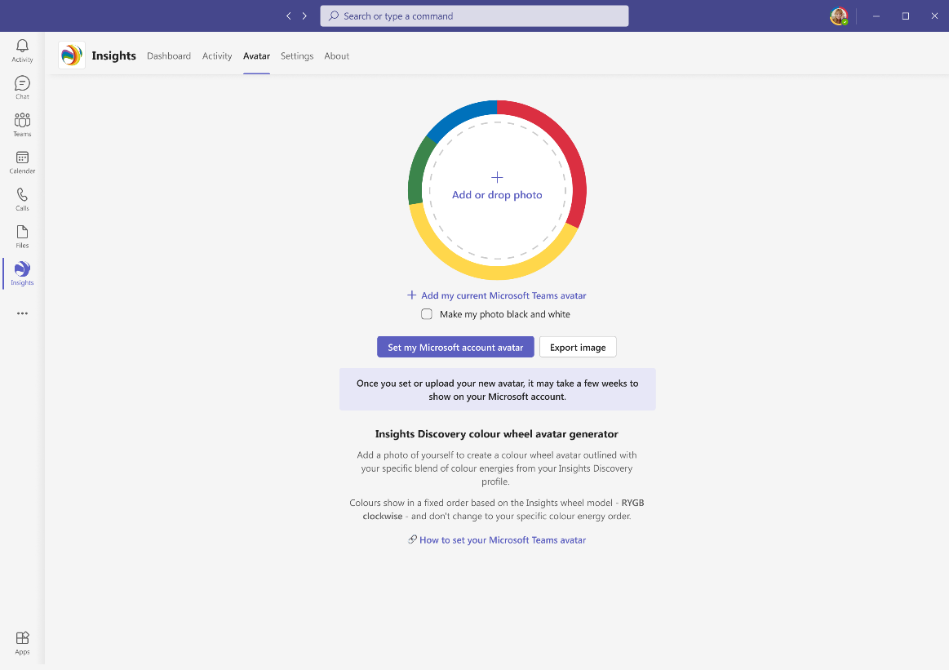
- You can upload a photo and use this image as your Microsoft Teams account avatar. 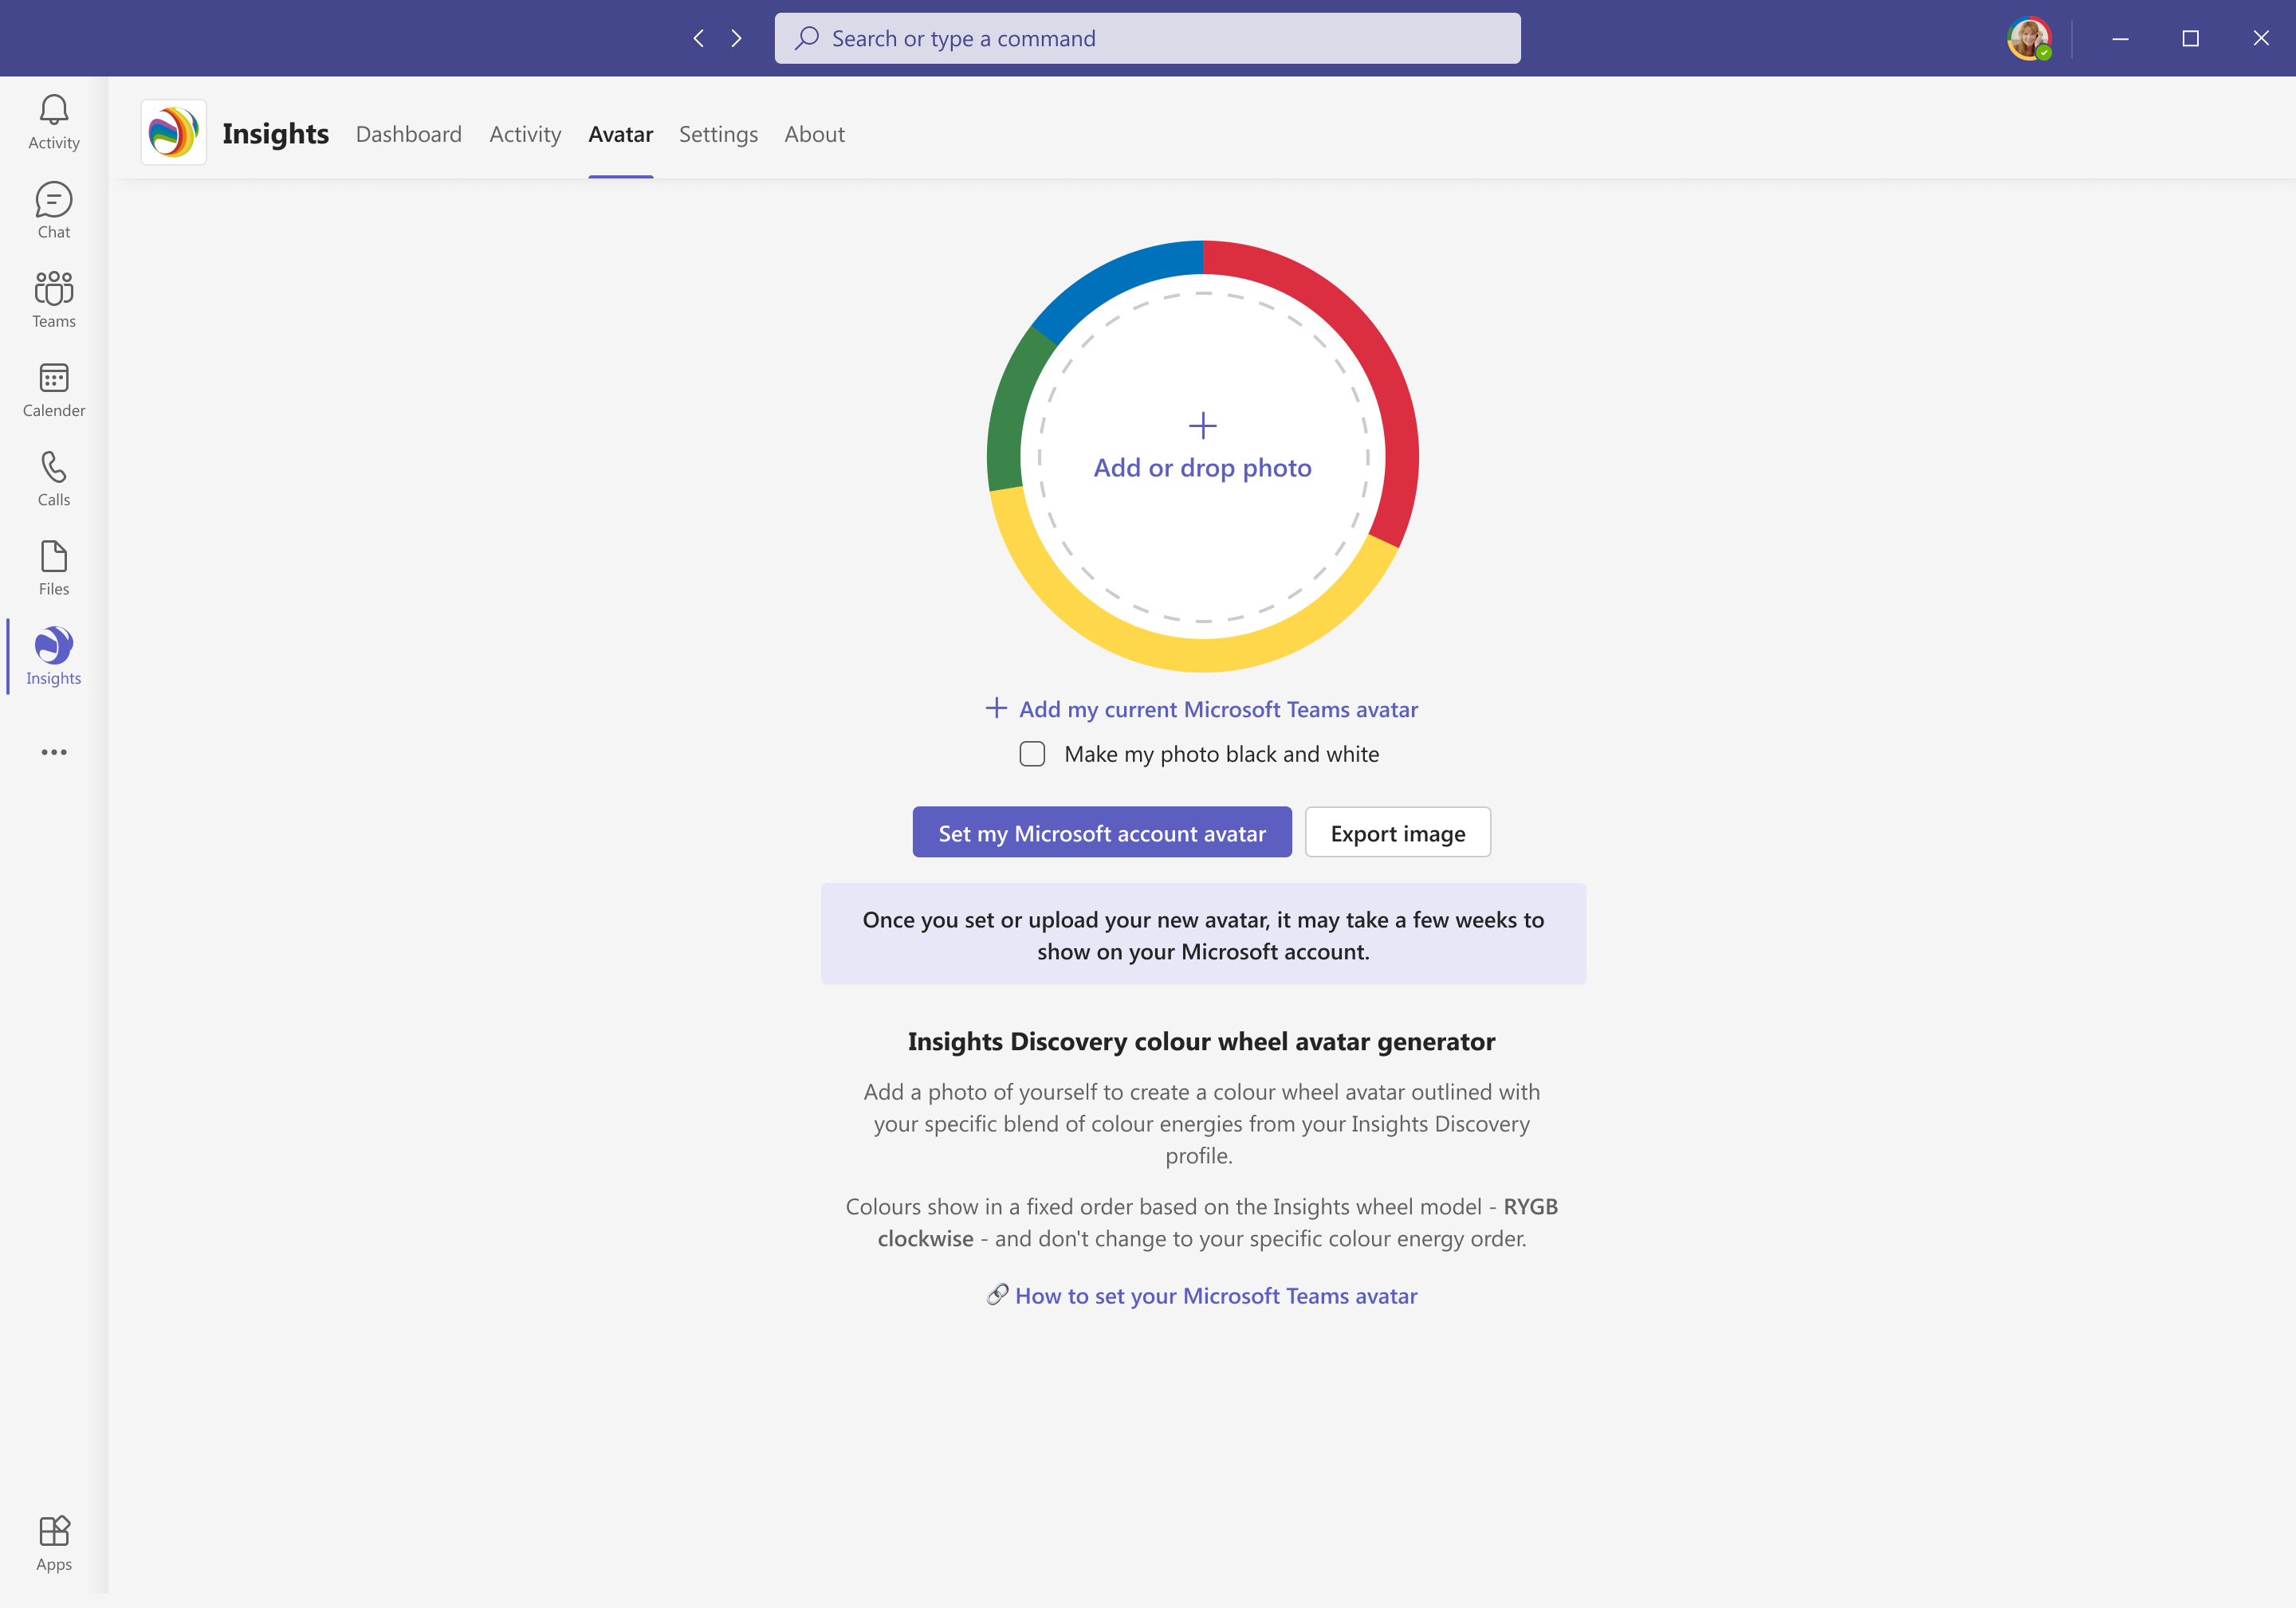
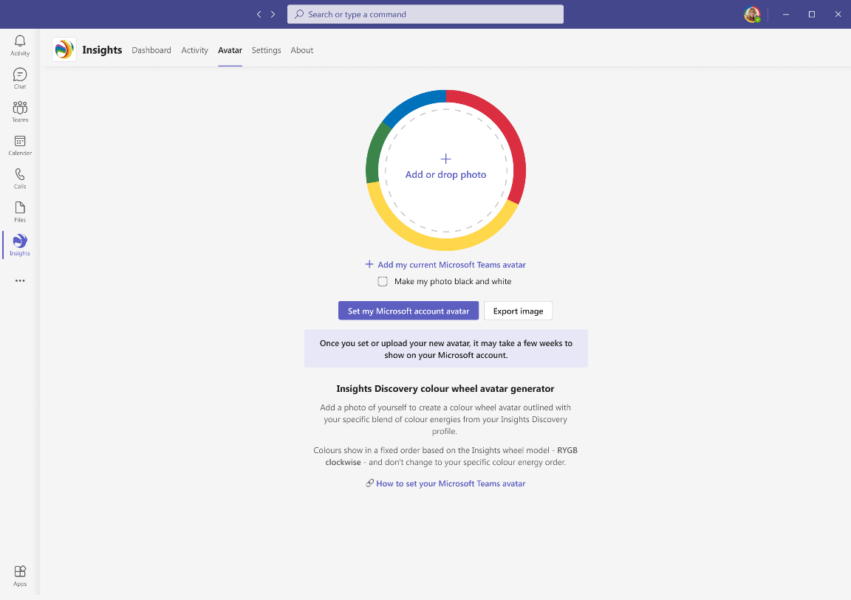
- Once your photo has been uploaded, your avatar will appear as shown below. 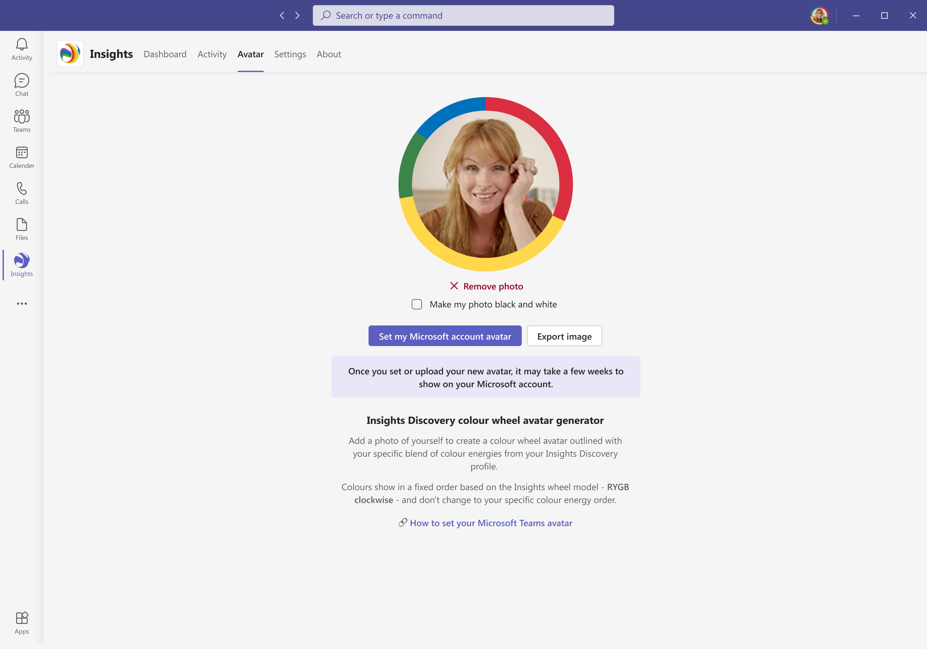
- Once set, your avatar will sync with your Microsoft Outlook account.
  - Please note that this may take 48-72 hours to complete.

Language settings
- If your Microsoft Teams language is set to English (EN), Danish (DA), German (DE), French (FR), Spanish (ES), or Dutch (NL), the entire app will be fully translated. This includes profile statements, weekly insights, buttons, headings, and other in-app text.
- If your Microsoft Teams language is set to a language listed below, profile statements will display in your selected Microsoft Teams language. All other parts of the app, including buttons and headings, will display in English.
Bulgarian | Hebrew | Romanian
Chinese (Simplified) | Hungarian | Russian
Chinese (Traditional)* | Italian | Serbian Latin
Croatian | Japanese | Slovenian
Czech* | Korean* | Spanish (Spain)
Estonian* | Lithuanian | Spanish (Mexico)
Finnish | Norwegian | Swedish
French (France) | Polish | Turkish
French (Canada) | Portuguese (Brazil) | Vietnamese**
Greek* | Portuguese (Portugal)
*Only statements from the foundation and management chapters in your Discovery profile will be translated.
** Only statements from the foundation, management and sales chapters in your Discovery profile will be translated.
- If your Microsoft Teams language is set to a language not mentioned above, the entire app will display in English. This includes profile statements, weekly insights, buttons, headings, and other in-app text.

Troubleshooting

Application Functionality
Q: Certain meetings are not displaying under the ‘Upcoming Meetings’ section. How do I resolve this?
A: Check your Settings and, under Important meeting sizes, ensure the relevant options are selected. 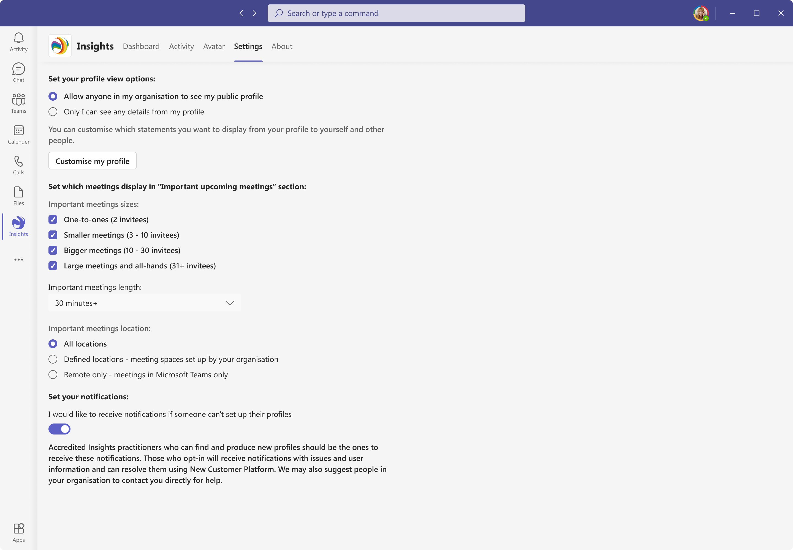
Also confirm that you are using the latest version of Microsoft Teams.
If the issue persists after checking these settings, please contact your account manager for further support.

Q: Can the settings area of the app be restricted by our IT department if we want certain settings to be the default (i.e. size of the meetings, customisation of the profile)?
A: Not at this time. IT administrators are not currently able to restrict or enforce default settings within the app.
This is a commonly requested feature and is on our product backlog for future consideration.

Profile Import Issues

Q: When I click ‘Confirm your profile’, it tells me there aren’t any profiles associated with my organisation and email address. What do I do?
A: If your profile has not imported, then you will see the below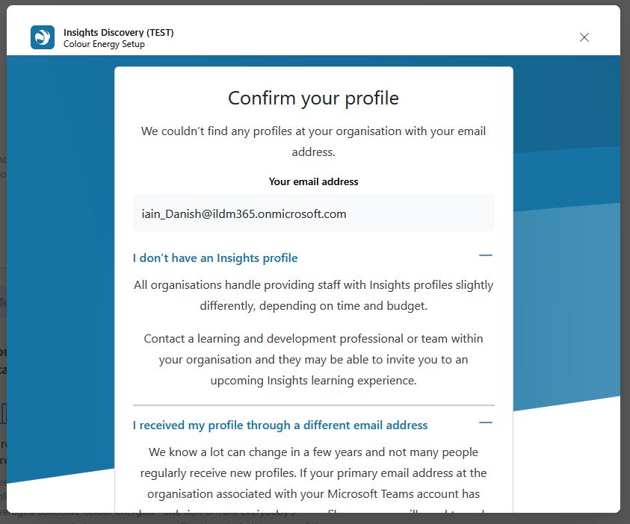
This could be due to any of the following:
- You do not have an Insights Discovery profile
  - If a user can access Insights Discovery for Microsoft Teams but doesn’t yet have a profile, they’ll need to be issued an Insights Discovery profile (by the L&D professional who administers Insights in your organisation) before they can use the app.
If you, as a practitioner, are receiving a large number of these requests, it may indicate that your IT department or Microsoft administrator has granted access to all users, rather than limiting it to those who already have profiles.
To resolve this, provide your IT team with a list of users who should have access, and ensure that app access is included in the onboarding processes for new employees where appropriate.
- You received a profile through a different email address
  - This issue may occur if a learner has changed their email address or used a different one to receive their new profile than the email linked to their Microsoft Teams account.
To resolve, log into the Insights New Customer Platform:
    - In the Learners & teams section, filter by the relevant organisation, then search for the learner by name.
    - Confirm the learner’s old and new email addresses.
    - Locate the learner record with the old email address and open their learner detail page.
    - Select ‘Edit learner’ at the top right of the page.
    - Replace the old email address with the new one in the Email address field, then select ‘Save details’.
Optional: You may need to assign the old learner record a placeholder (dummy) email address to make this possible.
    - Once saved, the correct learner record should appear the next time they confirm their profile via Microsoft Teams.
Note: this update may take up to an hour or more to sync with the app.
If this does not resolve the profile import, please reach out to your account manager for further support.
- Your profile is older than the 5-year retention period
  - To comply with GDPR, we have a 5-year retention period. In this instance, you would need to be issued an Insights Discovery profile by the L&D professional who administers Insights in your organisation.

FAQs

Application Functionality
Q: How do we see profile information in a Teams meeting about others in the meeting without sharing our screen?
A: In the meeting chat, if the Insights Discovery app has been added as a tab to the chat (see Adding app to meetings), by selecting it, the participants’ profile information will show in the meeting dashboard (see Meeting dashboard and chat drop downs).

Q: Are other meeting participants able to see profile information in advance or only when they are actually in the live call?
A: Once the app is added to a chat or a meeting everyone in that meeting who has downloaded the app can see the same as the meeting organiser. Anyone can click on the top meeting/chat ribbon Insights Discovery (see Adding app to meetings and Meeting dashboard and chat drop downs).

Q: What does the counter indicate next to the profile summary i.e. viewed 2 times this week?
A: This is how often you profile has been compared with someone else's.

Q: Can we roll this out in certain areas of the business only?
A: Yes, organisations work with their IT teams to determine who they want to be included in the roll out. See the setup guide for step-by-step instructions.

General
Q: Will Insights work on an Insights Discovery for other video conferencing systems?
A: Currently we are not. If this were to be considered in the future, it would be assessed in line with our security and privacy standards and communicated clearly to customers.

Q: Who owns the program long-term?
A: Insights own the application. Any changes to the application will be automatically updated.

Q: Is there any development happening with the use of your data in the app interacting with Copilot?
A: No. The app does not currently use customer data to interact with Microsoft Copilot, and there is no active development in this area.
If this were to be considered in the future, it would be assessed in line with our security and privacy standards and communicated clearly to customers.

Q: What are the steps if someone wants to opt out and delete the app?
A: The individual user can opt out by going to ‘Settings’ and select ‘Only I can see any details from my profile’. Their IT team would need to revoke their access in the Microsoft Admin Center for the app to be removed.

Q: Are non-employees (e.g. clients, partners) able to use the app and pull in their profile information during a call with employees?
A: No. Only employees associated with your organisation’s Microsoft tenant ID can use the app to view profile information.
External participants, such as clients or partners, are not linked to the tenant and therefore cannot access or pull in profile data during a call.

Q: Is my most recent profile pulled in or do I have the option to choose which profile to use?
A: Yes, it will be the most up to date Insights Discovery Personal Profile that will pull through. It is not automatic, but this is done when confirming your profile as you set it up. If you choose to do another Insights evaluator and want it updated. This will automatically sync. It will take around 15 minutes to update and pull through.

Q: Can I (or my customer) use the app if we’re still using Insights Online?
A: Organisations using the app must be on the New Customer Platform to pull relevant profile data. If you are still using Insights Online, please speak to your Account Manager to discuss migration.

Q: We don’t encourage learners to share profiles. Can this be turned off in the app?
A: Not by default, but users can individually choose to make their profiles private or customise their profiles to only display colour energy orders. Sharing with others is how learners get the most value out of their profiles in team and group settings.

Q: Are the app features available on the Microsoft Teams mobile app?
A: Absolutely. Navigation is slightly different, and the same information you see on desktop is available on the iOS and Android apps.

Q: Can evaluators be completed through the app?
A: No.

Security
Q: What are your policies on GDPR compliance, data retention, and data privacy?
A: Please see our General Privacy Notice | Insights

Q: Does the application transmit data outside of an organisation?
A: No data will be transmitted outside of an organisation for the application.

Q: What type of data does the application capture/pass between systems?
A: The app only works if the individual has an Insights Discovery profile - we don't collect anything new for this. When using our app, we will process the following:
- Profile data - your existing Insights Discovery profiles and colour preferences
- Basic Microsoft info - email, display name, profile photo, user ID
- App settings - language preferences and user customisation
What we don’t collect: special category data or data from people without existing profiles

Q: How has the security of this application been tested?
A: The security of this product has been independently tested by Barrier, a third-party security provider through a comprehensive security penetration test.
This assessment was designed to identify potential vulnerabilities and ensure the application meets recognised security standards. A high-level executive summary of the penetration test is available for review here: Insights Microsoft Teams Application Security Assessment 2024 - Executive Summary.pdf.

Technology
Q: What permissions does the application require?
A: See the setup guide.

Q: What is the app built with?
A: It’s a web app built with React that only runs within Microsoft Teams.

Q: How is the app deployed?
A: See the setup guide.

Q: How does the app communicate with the practitioner platform?
A: The app pulls learner data from our practitioner platform using a secure API.

Q: How is the app patched?
A: Changes, fixes and updates can be deployed to the underlying web app at any time. If we make changes that require new interactions with Microsoft Teams core features, we’ll need to resubmit the app through the Microsoft app store. Once a new version is approved, it should be automatically available to all users.

Q: How is personal data stored?
A: The app caches data for quick access, which is refreshed every 24 hours. The cache stores email addresses, profile data, user IDs, display names, profile photos and app settings.

Q: Why are application-level permissions required and can the app function without them?
A: Application-level permissions are required to support installation of the Insights Discovery for Microsoft Teams bot via MS Graph API. This allows the app to be automatically deployed to your Microsoft Teams environment without the need for each user to install it manually.

Microsoft requires permissions for this action because it involves modifying resources beyond what the user can see or access, something which delegated permissions don’t allow.

